Table of Contents
Introduction 3
System Design 3
Fields 4
Validation Checks 4
Testing 6
Before Testing: 6
After Testing (invalid input): 6
Code 7
Grouping the gender radio buttons 7
Helper methods 7
Length check (ID example) 8
GitHub Repository 8
Conclusion 8
What I learned: 9
References 9

Introduction
This is a Java Swing desktop form, built in NetBeans, called the “Data Validation System.” It collects a person’s details and checks that each entry is in the correct format before it is accepted. The Save button checks every field to ensure that nothing is empty, names contain letters only, the ID number contains exactly 13 digits, the age is between 18 and 100, the contact number contains 10 digits, and the email address follows a valid format. Fields that fail validation are indicated in red on their corresponding labels, while a success message is displayed when all the information is entered correctly. The Clear button empties all fields and resets the labels, Help displays the input requirements, and Exit closes the application.
The purpose of this system is to demonstrate input validation, which is the process of preventing incorrect, incomplete, or invalid data from being stored or processed. The system demonstrates three common types of validation: presence validation, which checks whether required fields have been completed; type validation, which ensures that the correct type of characters, such as letters or digits, is entered; and format and range validation, which checks requirements such as the correct length, valid age range, and email format.

System Design
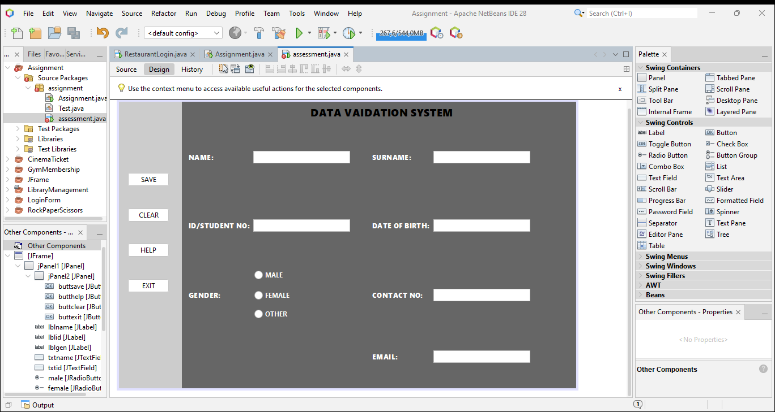
The main area is dark grey, and the button panel is light grey. Together they give a neutral, professional look that separates actions from data entry. Field labels are white and bold for strong contrast against the dark background. Validation errors turn the label red. Red is the conventional colour for errors, so users understand it without explanation.
Button panel (left): SAVE, CLEAR, HELP and EXIT sit in one vertical column, so all actions are in one predictable place away from the data fields.
Title (top, centred): a 18pt bold heading that states the purpose of the form.
Two-column field grid: name, ID and gender go on the left, and surname, date of birth, contact number and email on the right. Labels sit to the left of their fields, which follows the usual left-to-right reading pattern.
Gender radio buttons: MALE, FEMALE and OTHER are stacked, so the user picks one option from a short list.
Each field reports its own error on its own label, so the user can see exactly what to fix, labels return to normal on the next save or on Clear, so old errors don't linger, the Help button lists the input rules, the radio buttons are grouped so only one can be selected, Clear and Exit give the user a way to start over or leave.

Fields
Field | Component name | What it captures
Name | txtname | The person's first name (letters only)
Surname | txtsur | The person's last name (letters only)
ID/student no | txtid | A 13-digit identification or student number
Date of birth | txtdob | Currently captures an age (18–100), not an actual date — see note below
Gender | male, female, other | One selected option from three radio buttons
Contact no | txtcont | A 10-digit phone number
Email | txtemail | The person's email address

Validation Checks
Field | Checks applied | Why appropriate
Name | Presence, Type ([A-Za-z]+) | A name can't be blank, and it should contain letters only — digits or symbols in a name field usually signal a typo or bad input, so a type check catches that early.
Surname | Presence, Type ([A-Za-z]+) | Same reasoning as Name — surnames are alphabetic, so blocking digits/symbols keeps the data clean.
ID/student no | Presence, Type (\d+), Length (exactly 13) | An ID must exist to identify the person, must be numeric since IDs are digit sequences, and a fixed length matters because ID numbers (e.g. a national ID) follow a strict standard — anything shorter or longer is definitely wrong, even before checking what it means.
Date of birth (age) | Presence, Type (numeric, via parseInt), Range (18–100) | Presence and type stop empty or non-numeric entries. The range check is a plausibility check — it doesn't confirm the age is true, but it rules out impossible values (e.g. 3 or 250), which is a sensible sanity check for a system that likely requires adult users.
Gender | Presence (one radio button selected) | This is a selection field rather than free text, so type/format/length don't apply. The only meaningful check is that the user made a choice at all — otherwise the record is incomplete.
Contact no | Presence, Format (\d{10} — exactly 10 digits) | Combines type and length into one regex: digits only, and exactly 10 of them, matching a standard local phone number format. A format check is more appropriate than separate type/length checks here because the two conditions (digits + count) are really one rule about what a valid number looks like.
Email | Presence, Format (^[\w.+-]+@[\w-]+(\.[\w-]+)+$) | Presence stops blank submissions. Format is the correct check (rather than type or length) because an email's validity depends on its structure — the @ symbol, a domain, and a valid extension — not on length or character type alone.

Testing

Before Testing:
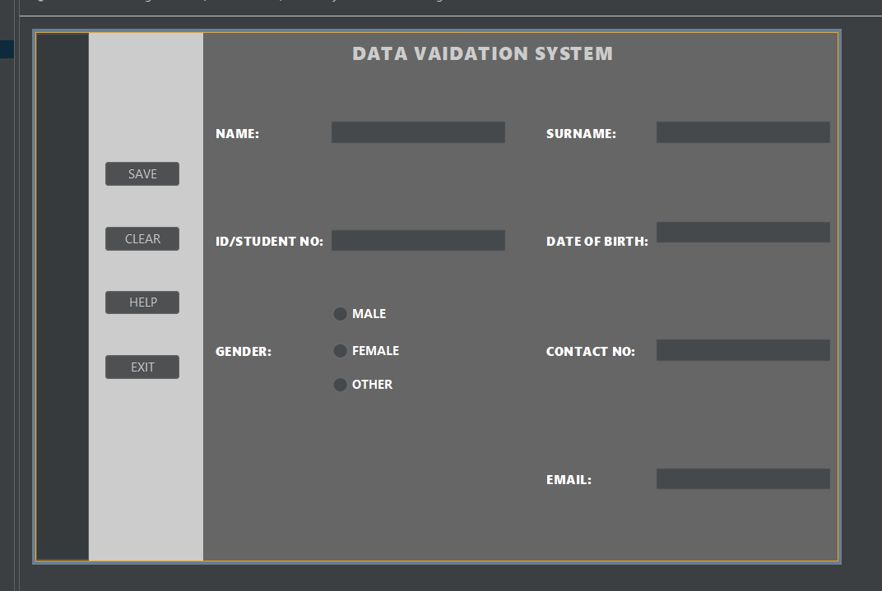

After Testing (invalid input):
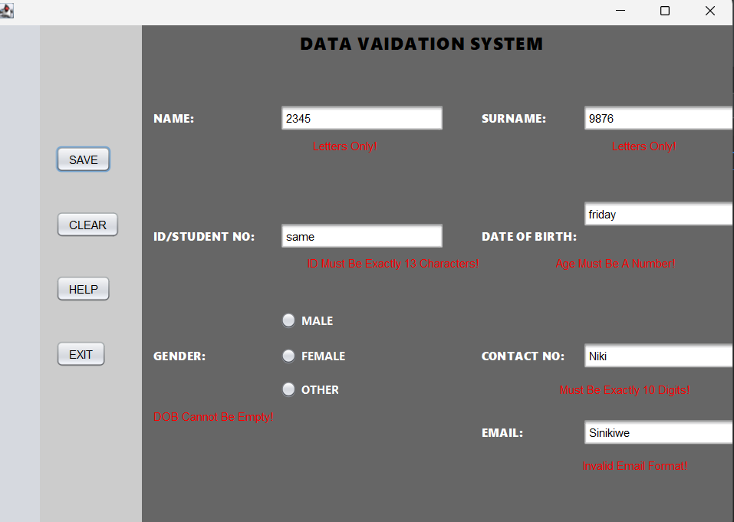

Code

Grouping the gender radio buttons
java
private final javax.swing.ButtonGroup genderGroup = new javax.swing.ButtonGroup();

public assessment() {
initComponents();
genderGroup.add(male);
genderGroup.add(female);
genderGroup.add(other);
}
A ButtonGroup links the three radio buttons so that selecting one automatically deselects the others. Without it, a user could tick Male, Female and Other at the same time, which makes no sense for a single-choice field.

Helper methods
java
private void showError(javax.swing.JLabel label, String message) {
label.setForeground(Color.RED);
label.setText(message);
}

private void resetLabels() {
javax.swing.JLabel[] labels = {lblname, lblsur, lblid, lbldob, lblgen, lblcont, lblemail};
String[] texts = {"NAME:", "SURNAME:", "ID/STUDENT NO:", "DATE OF BIRTH:", "GENDER:", "CONTACT NO:", "EMAIL:"};
for (int i = 0; i < labels.length; i++) {
labels[i].setText(texts[i]);
labels[i].setForeground(Color.WHITE);
}
}
showError avoids repeating the same two lines (colour + text) for every failed check. resetLabels puts every label back to its normal white text and original wording before each validation run, so an old error message can't linger on screen after it's been fixed.

Length check (ID example)
java
if (id.isEmpty()) {
showError(lblid, "ID Required!");
isValid = false;
} else if (!id.matches("\\d+")) {
showError(lblid, "Digits Only!");
isValid = false;
} else if (id.length() != 13) {
showError(lblid, "Must Be 13 Digits!");
isValid = false;
}
Three checks are chained: presence, then type (digits only), then length (exactly 13 characters). They're ordered from most basic to most specific, so the user gets the most relevant message rather than several at once.

GitHub Repository

Conclusion
The biggest challenge was implementing real-time validation without crashing the program. At first I used `KeyListener` which failed when pasting text, then I learned `DocumentFilter` which is more professional. The gender group was also confusing until I understood it must be added AFTER `initComponents()` and assigned in Properties.

What I learned:
- How to combine 5 validation types in one system
- Importance of UI design - colour and spacing matters for marks
- How to use GitHub with meaningful commits
- How to give user-friendly error messages instead of technical Java errors

This project improved my Java Swing and validation logic skills and I can now build a professional registration form for any business.

References
1. Oracle Java Documentation - Swing JTextField and DocumentFilter
2. From class - How to Use Radio Buttons
3. TutorialsPoint - Java Swing Tutorial
4. Stack Overflow - Email regex validation in Java
5. Class - NetBeans GUI Builder tutorial

